**corona track app**

**with BigTangle blockchain**

**Dr. Jianjun Cui and Wolfgang Blumental**

[**cui@inasset.de**](mailto:cui@inasset.de)

**wechat: cui8161188**

# Summary

Across the world, governments, and health authorities are working together to find solutions to the COVID‑19 pandemic, to protect people and get society back up and running. Software developers are contributing by crafting technical tools to help combat the virus and save lives.

The Bigtangle provides a decentralized identity solutions to power the 4th industrial revolution and internet of things, bringing secure identities to person, machines, algorithms, and other non-human entities. The Bigtangle is a public block chain with inherent exchange service, Near-Time Confirmation, Infinite Scalability, Feeless, Permissionless, Trustless, and Decentralized.

For the collect of data, we do use the Google and Apple Bluetooth technology.

Table of Contents

Summary 2

3

BigTangle Corona Track 4

Public Key as Anonymous identifier to collect contact data 4

Decentralized Authority 4

Decentralized Contact Tracing 4

Implementation 5

Create Domain Health Authority 5

Create Corona Virus Token 6

Transfer virus token to user. 7

Reference 8

# 

# BigTangle Corona Track

## Public Key as Anonymous identifier to collect contact data

Each phone with Bigtangle wallet broadcasts over a short distance the public address as anonymous identifier. Contact data between phones of users are estimated by measuring radio signals (Bluetooth, etc.) using well tested and calibrated algorithms. The data will be saved with time stamp and public key.

### Decentralized Authority

Distributed authority can create corona virus token and risk corona virus for each country and distributed authority will transfer the corona virus token to user, which has been confirmed to be SARS-CoV-2 positive.

### Decentralized Contact Tracing

The Bigtangle wallet can query all public addresses which has corona virus token with issue date. Then it can check the local contact data. If the check find contact risk, then the user may inform the authority and will get a risk corona virus token. This will enable the check of infection chain.

# Implementation

### Create Domain Health Authority

Bigtangle has a distributed domain name service similar to internet domain name system. There is system group to enable the creation of top domain name gov, com etc. The owner group of top domain can create new sub domain with multi signature. The domain name is unique and protected by multi signature. All token belongs to a domain name and is then also unique in the form of [tokenname@domainname](mailto:tokenname@domainname).

The domain name is health authority germany.com

<https://testcc.bigtangle.xyz/vm/group.jsf>

### 

### Create Corona Virus Token

The corona virus token will be created by domain owner group with full token name as

corona virus@health authority germany.com

### 

### Transfer Virus Token To User.

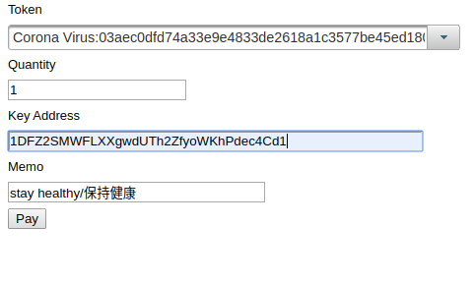

# Reference

[1.](https://github.com/DP-3T/documents) Decentralized Privacy-Preserving Proximity Tracing

https://github.com/DP-3T/documents

2. https://bigtangle.net

3. Apple and Google Proposal

https://www.apple.com/newsroom/2020/04/apple-and-google-partner-on-covid-19-contact-tracing-technology/

4. PEPP-PT

<https://www.pepp-pt.org/>